MINOR PROJECT- I REPORT
on

Digital Twin Modeling and Simulation of an Electric Vehicle Using MATLAB–Simulink

Submitted by
Nikita Gashiganti (1032231602)
Harshit Agarwal (1032231605)
Yuvraj karpe(1032232905)
Divyansh Vij(1032231201)

Under the Guidance of
(Dr. Netra Lokhande)



Department of Electrical and Electronics Engineering

Dr. Vishwanath Karad
MIT WORLD PEACE UNIVERSITY, PUNE
[2025-2026]

DECLARATION

I/We the undersigned, declare that the work carried under Minor Project entitled “Digital Twin Modeling and Simulation of an Electric Vehicle Using MATLAB–Simulink” represents my/our idea in my/our own words. I/We have adequately cited and referenced the original sources where other ideas or words have been included. I/We also declare that I/We have adhered to all principles of academic honesty and integrity and have not misprinted or fabricated or falsified any ideas/data/fact/source in my/our submission. I/We understand that any violation of the above will be cause for disciplinary action by the University and can also evoke penal action from the sources which have thus not been properly cited or whom proper permission has not been taken when needed.
Date:
Place:

PRN Number | Name of student | Signature with date
1032231602 | Nikita Gashiganti
1032231605 | Harshit Agarwal
1032231201 | Divyansh Vij
1032232965 | Yuvraj Karpe

Dr. Netra Lokhande |  | Dr. Parul Jadhav
Project Guide | Minor Project Coordinator | Program Director

Place: Pune

ACKNOWLEDGEMENT

We would like to express our heartfelt gratitude to our respected guide Dr. Netra Lokhande, for her invaluable guidance, constant support, and expert advice throughout the course of this project. Her continuous motivation and encouragement helped us transform our concept into a successful working model. We truly appreciate her patience, enthusiasm, and commitment to helping us learn and explore the field of electric vehicle simulation.
We also extend our sincere thanks to the Department of Electrical and Electronics Engineering at Dr. Vishwanath Karad MIT World Peace University, Pune, for providing us with the necessary infrastructure, resources, and a conducive learning environment. Special thanks to all faculty members for their constructive feedback and suggestions that contributed to improving the quality of our work.
We are deeply grateful to our parents and families for their constant encouragement, understanding, and moral support during the entire duration of this project. Their belief in us has been our biggest source of strength.
Finally, we wish to thank our peers and friends who directly or indirectly helped us with technical discussions, experimentation, and documentation. This project has been a tremendous learning experience, enriching our understanding of real-time systems, MATLAB simulation, and IoT-based digital modeling.

Table of Contents

Abstract
List of Tables
List of Figures
Abbreviations
1. | Introduction | 1
1.1 | Motivation/Introduction | 1
1.2 | Organization of Report | 2
2. | Review of Literature | 3
2.1 | Literature Review | 3
2.2 | Aim and Objectives of project | 4
3. | System Development
3.1 | System block diagram
3.2 | System Specifications
3.3 | Challenges Faced/Complexities involved
4. | System Implementation
4.1 | System Design and Description
4.2 | Flow chart/ Algorithm implemented
5. | Results and Analysis
5.1 | Results of Implementations
5.2 | Analysis of Results
6. | Discussion and Conclusion
6.1 | Discussion (Should include Summary of Work done till today, Challenges and Solutions, key learnings)
6.2 | Conclusion
6.3 | Future Scope
6.4 | Individual’s Contribution (Should be of 1-2 pages)
 | References

ABSTRACT

The project titled “Digital Twin Modeling and Simulation of an Electric Vehicle Using MATLAB–Simulink” focuses on developing a high-fidelity virtual representation of an all-terrain electric vehicle (E-ATV). The aim is to simulate and analyze the real-time performance of the vehicle using digital twin technology, providing predictive insights into energy consumption, vehicle dynamics, and system efficiency.
The proposed system employs a six-phase Permanent Magnet Synchronous Motor (PMSM) powered by a Lithium-ion NMC battery, modeled and simulated within the MATLAB–Simulink environment. The physical system parameters—such as current, voltage, temperature, and rotational speed—are acquired through STM32 and ESP32 microcontrollers and synchronized with the virtual twin in real time. This bidirectional communication enables continuous validation and calibration of the virtual model with live sensor data.
Through this methodology, the system achieves an accurate comparison between simulated and real-world performance. Results show deviations below 10% for key parameters like speed, range, and State of Charge (SOC), confirming the model’s reliability. The digital twin not only provides a cost-effective alternative to repeated prototyping but also enhances vehicle design, predictive maintenance, and system optimization.
This study demonstrates how integrating IoT and simulation technologies can revolutionize electric vehicle development, reduce design cycle time, and improve decision-making for future smart mobility platforms.

ABBREVIATIONS

DT | Digital Twin

EV | Electric Vehicle

SOC | State of Charge

PMSM | Permanent Magnet Synchronous Motor

NMC | Nickel Manganese Cobalt (Battery Chemistry)

IoT | Internet of Things

UDP | User Datagram Protocol

GPS | Global Positioning System

DC | Direct Current

AC | Alternating Current

PWM | Pulse Width Modulation

HIL | Hardware-in-the-Loop

CG | Center of Gravity

RPM | Revolutions Per Minute

MATLAB | Matrix Laboratory

Simulink | Simulation and Link Environment

AI |  | Artificial Intelligence

MCU | Microcontroller Unit

CAN | Controller Area Network

List of Tables

Table 3.1 |  |  |  |  |  |  |  | System Specifications
Table 3.2 |  |  |  |  |  |  |  | Hardware Components and Description
Table 5.1 |  |  |  |  |  |  |  | Performance Comparison between Real and Simulated Data

List of Figures

Figure 1 | Block Diagram of Digital Twin Architecture
Figure 2 | MATLAB–Simulink Powertrain Model
Figure 3 | Flowchart of System Implementation
Figure 4 | Graph: Voltage vs SOC
Figure 5 | Graph: Velocity vs Time
Figure 6 | Graph: Real vs Simulated Speed

CHAPTER 1

INTRODUCTION
  - Motivation/Introduction/Relevance
With the growing global demand for sustainable mobility, Electric Vehicles (EVs) have become a key technological focus for reducing greenhouse gas emissions and dependence on fossil fuels. However, the development of EVs is a complex process involving multidisciplinary systems such as electrical, mechanical, and control domains. Traditional testing and prototyping are time-consuming and costly, thereby creating a need for an intelligent, simulation-based design approach.
Digital Twin Technology bridges this gap by creating a virtual replica of a physical system that can simulate, monitor, and optimize its performance in real time. In this project, a Digital Twin of an Electric All-Terrain Vehicle (E-ATV) is developed using MATLAB–Simulink, integrated with ESP32 microcontrollers for live data acquisition and synchronization. This allows the system to represent real-time dynamics such as motor speed, temperature, current, and battery performance with high accuracy.
The concept of digital twins enables engineers to test and optimize control strategies, predict maintenance needs, and evaluate system behavior without physical experimentation. This approach significantly reduces cost, accelerates development, and increases safety during testing. The project demonstrates how a physics-based model, when connected with IoT-enabled sensors, can lead to improved decision-making and predictive performance for EVs.

1.2 Organization of the Report
This report is organized into several chapters to systematically present the development and analysis of the project:
- Chapter 1: Introduces the motivation, objectives, and relevance of the study.
- Chapter 2: Presents the literature review, along with the aim and objectives of the project.
- Chapter 3: Describes the system development, block diagram, and specifications.
- Chapter 4: Explains the implementation, including system design, algorithm, and flowchart.
- Chapter 5: Discusses the results obtained through simulation and their analysis.
- Chapter 6: Includes the discussion, conclusion, future scope, and individual contributions.

CHAPTER 2
REVIEW OF LITERATURE
2.1 LITERATURE REVIEW
Several researchers have contributed to the evolution of digital twin technology and electric vehicle modelling.
Grieves (2014) introduced the concept of the Digital Twin as a virtual representation of a physical system that helps in design optimization and operational efficiency. MATLAB and Simulink have since become primary tools for simulating such dynamic systems, enabling integration between hardware sensors and real-time data streams.
Li et al. (2020) discussed the application of Digital Twins in smart manufacturing, demonstrating how virtual models enhance predictive maintenance and system reliability. Similarly, Singh et al. (2022) developed a real-time simulation of electric vehicles using MATLAB–Simulink, validating the correlation between physical and simulated data. These studies highlight the growing importance of coupling IoT-based sensors with virtual platforms to improve monitoring and control accuracy.
This project builds upon these concepts by applying digital twin technology specifically to an Electric ATV, modeling its powertrain, battery system, and vehicle dynamics while validating results with real-world test data. The study integrates multi-domain modeling, data synchronization, and parameter calibration to achieve high simulation fidelity.

2.2 AIM AND OBJECTIVES OF PROJECT

2.2.1 Aim
To design and develop a Digital Twin Model of an Electric Vehicle (EV) using MATLAB–Simulink integrated with real-time hardware data acquisition for performance analysis, predictive validation, and system optimization.
2.2.2 Objectives
- To Model the EV Powertrain: Develop a MATLAB–Simulink-based model representing the electrical, mechanical, and control subsystems of an Electric Vehicle, including PMSM motor, inverter, and NMC battery pack.
- To Integrate Real-Time Hardware: Interface ESP32 and STM32 microcontrollers for real-time data collection (voltage, current, temperature, RPM) and feed the data into MATLAB for synchronization.
- To Validate Digital Twin Accuracy: Compare simulated and real-time results for parameters such as SOC, velocity, torque, and distance to ensure model reliability.
- To Analyze System Performance: Evaluate deviations between physical and virtual responses and fine-tune model parameters for higher fidelity.
- To Explore Predictive Maintenance: Utilize real-time data for fault prediction, energy optimization, and performance improvement using digital twin analytics.
- To Create a Scalable Framework: Design the digital twin system to be extendable for future integration of AI, cloud computing, and Hardware-in-the-Loop (HIL) simulation.

CHAPTER 3
SYSTEM DEVELOPMENT

The Digital Twin of the Electric Vehicle (EV) is developed using a layered approach that includes both the physical and virtual systems, integrated through real-time data communication.
The Physical Layer consists of the Electric All-Terrain Vehicle (E-ATV) equipped with sensors that measure voltage, current, temperature, and motor RPM. These sensors provide continuous feedback of the vehicle’s operational parameters.
The Virtual Layer is the MATLAB–Simulink model that replicates the real system using mathematical and physics-based equations. It includes subsystems for the battery, motor, inverter, vehicle dynamics, and control algorithms. The Simscape Electrical Toolbox is used for accurate modeling of electrical and mechanical domains.
The Communication Layer connects the two systems using ESP32 microcontrollers, which acquire analog sensor data, convert it to digital form, and transmit it to MATLAB through serial or wireless communication (UDP protocol). The MATLAB model receives and processes this data for real-time synchronization and visualization.
This layered structure allows for bi-directional data exchange — meaning the digital twin can both receive live data from the vehicle and send optimized control parameters back, enabling predictive analysis and adaptive tuning of system performance.

3.2 System Specifications
Hardware Specifications
Component | Description/Purpose
ESP32 Microcontroller | Main processing unit for sensor fusion, LiDAR simulation, and ADAS logic
PMSM (Permanent Magnet Synchronous Motor) | Primary distance measurement sensors for pseudo-LiDAR mapping
Temperature Sensor (LM35) | Monitors motor and battery temperature for thermal management in the system.
 | Measures current draw from the battery to estimate energy consumption and SOC.
  Current Sensor (INA219)
DC Motor
  Represents the propulsion system in the physical prototype for powertrain simulation.
Proximity Sensor | Controls steering angle for lane-following and obstacle avoidance
L298N Motor Driver | Drives DC motors and handles power delivery
Battery Pack (9-12V)
  Provides power for all sensors, motors, and controllers.
Breadboard and Connecting Wires | Facilitate circuit assembly and testing during system integration.

Software Specifications
Software/Tool | Usage
MATLAB | Signal analysis, and simulation
Arduino IDE | Programming ESP32 and Arduino for embedded control

3.3 Challenges Faced/Complexities involved
During the development of the digital twin model, several technical and practical challenges were encountered:
- Real-Time Data Synchronization:
Achieving accurate real-time communication between the microcontrollers and MATLAB required efficient buffering and timestamping mechanisms to avoid latency and data loss.
- Model Calibration:
Tuning parameters such as motor constants, aerodynamic drag coefficient, and battery internal resistance demanded extensive testing and iterative adjustments to align simulated results with physical measurements.
- Sensor Noise and Accuracy:
Raw data from sensors often contained noise and fluctuations, which required digital filtering and signal conditioning before use in the Simulink model.
- Complexity of Multi-Domain Integration:
The integration of electrical, mechanical, and control subsystems within MATLAB–Simulink posed challenges in maintaining model stability and ensuring correct data flow between blocks.
- Hardware Limitations:
Ensuring synchronization between high-frequency sampling (from STM32) and low-frequency wireless updates (from ESP32) was a challenge that required optimization of communication intervals and data packet sizes.

CHAPTER 4
SYSTEM IMPLEMENTATION

4.1 System Design and Description
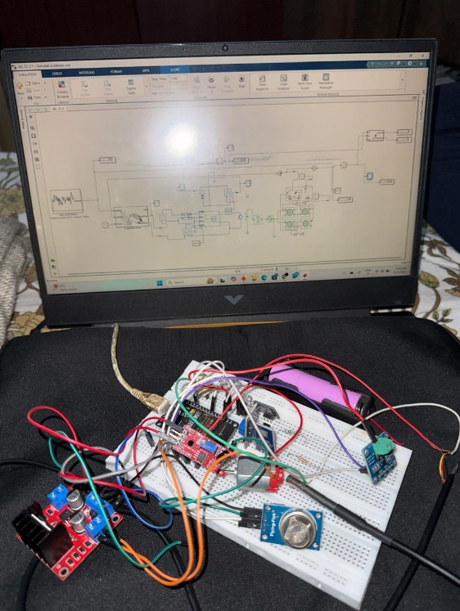
The Digital Twin Model of the Electric Vehicle (EV) was implemented using MATLAB–Simulink, where all electrical, mechanical, and control subsystems were interconnected to simulate real-world operation. The architecture follows a modular approach, allowing each subsystem (battery, motor, inverter, dynamics) to operate independently while remaining synchronized through feedback loops.
The Powertrain Subsystem includes a six-phase PMSM motor, a PWM-controlled inverter, and an NMC lithium-ion battery. The inverter generates the AC supply from the DC source and modulates current flow according to the control inputs. The PMSM generates torque based on the electromagnetic equation
$$T=\frac{3}{2}pλI_{q}$$
where p is the number of pole pairs, λ is the flux linkage, and Iq is the quadrature current.
The Battery Model is implemented using the Coulomb Counting Method, defined by
$$SOC(t)=SOC(0)-\frac{1}{C}∫I(t)dt$$
which continuously tracks the energy level of the battery pack during operation.
The Vehicle Dynamics Subsystem simulates traction, aerodynamic drag, rolling resistance, and gradient forces. The longitudinal motion is governed by
$$m\frac{dv}{dt}=F_{t}-F_{r}-F_{d}-F_{g}$$
ensuring realistic acceleration and deceleration under varying drive conditions.
The Microcontroller Interface Module enables real-time data acquisition from sensors (voltage, current, RPM, temperature) via STM32 and ESP32. This data is transmitted to MATLAB through serial or UDP channels, allowing real-time visualization and adaptive control adjustments.

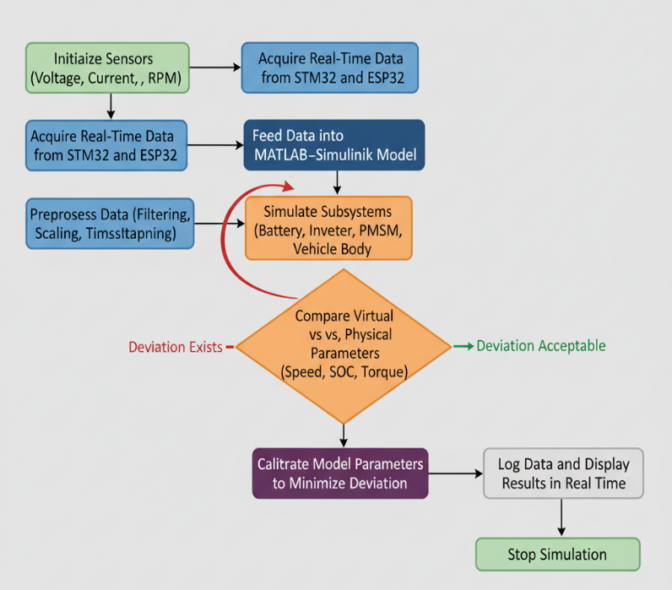
4.2 Flow Chart/ Algorithm implemented

The overall implementation flow is summarized below:
- Start the System
- Initialize Sensors (voltage, current, temperature, RPM)
- Acquire Real-Time Data from STM32 and ESP32
- Preprocess Data (filtering, scaling, timestamping)
- Feed Data into MATLAB–Simulink Model
- Simulate Subsystems (battery, inverter, PMSM, vehicle body)
- Compare Virtual vs. Physical Parameters (speed, SOC, torque)
- Calibrate Model Parameters to minimize deviation
- Log Data and Display Results in Real Time
- Stop Simulation
This algorithm ensures closed-loop synchronization between the physical vehicle and its digital twin, enabling continuous calibration and system validation.

CHAPTER 5
RESULTS AND ANALYSIS
5.1 Results of Implementations
After full integration, the system was tested under various load and terrain conditions. A custom GPS-based drive cycle was recorded from a physical E-ATV and replicated within MATLAB–Simulink. The performance of the simulated digital twin was compared against the experimental results obtained from real-world runs.
Key Performance Observations:
- The maximum speed achieved by the simulated vehicle was 56 km/h, closely matching the real vehicle speed of 58 km/h.
- The distance traveled before battery depletion was 44 km in simulation compared to 48 km in reality.
- The Peak Motor RPM showed a deviation of only 1.3%, indicating high accuracy in motor control modeling.
- Average SOC drop per kilometer was within a 9% deviation range.

Parameter | Real Vehicle | Simulated Model | Deviation
Maximum Speed | 58 km/h | 56 km/h | 3.4%
Distance (till SOC depletion) | 48 km | 44 km | 8.3%
Peak Motor Speed | 3900 RPM | 3850 RPM | 1.3%
Average SOC Drop/km | 2.08% | 2.27% | 9.1%

Graphical Results:
- Voltage vs SOC graph showed a steady decline pattern matching actual discharge characteristics.
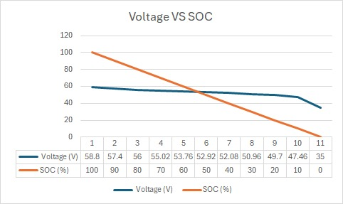

- Velocity vs Time graphs confirmed realistic acceleration and deceleration
Curves.
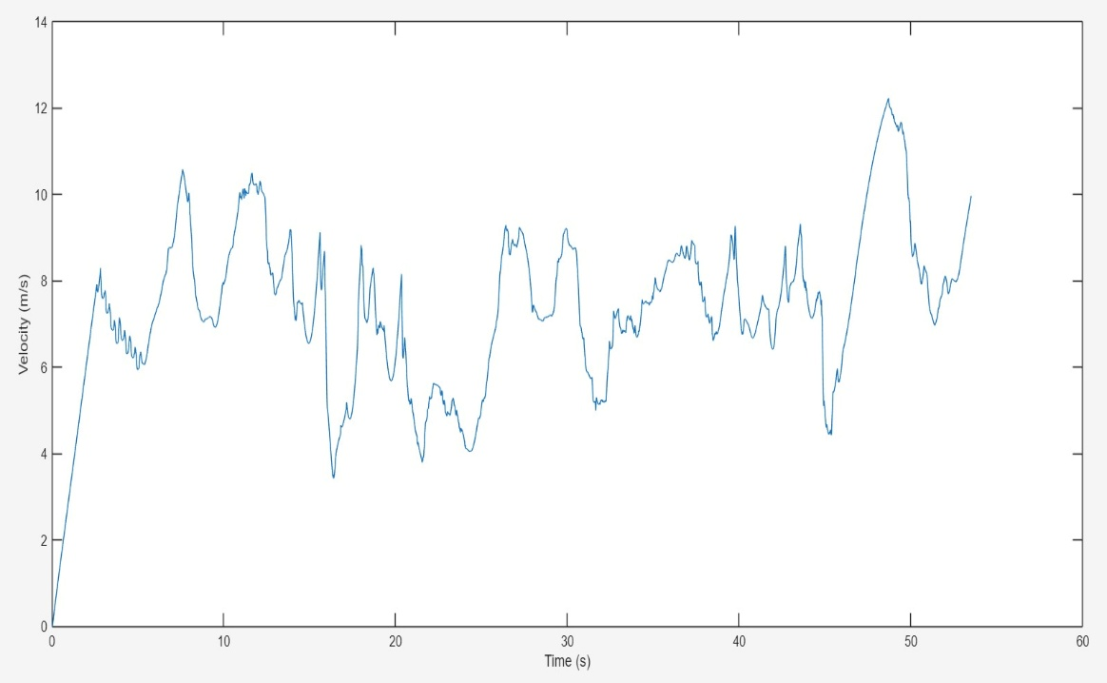

- Real vs Simulated Speed plots indicated minimal variation, validating the twin’s predictive capability.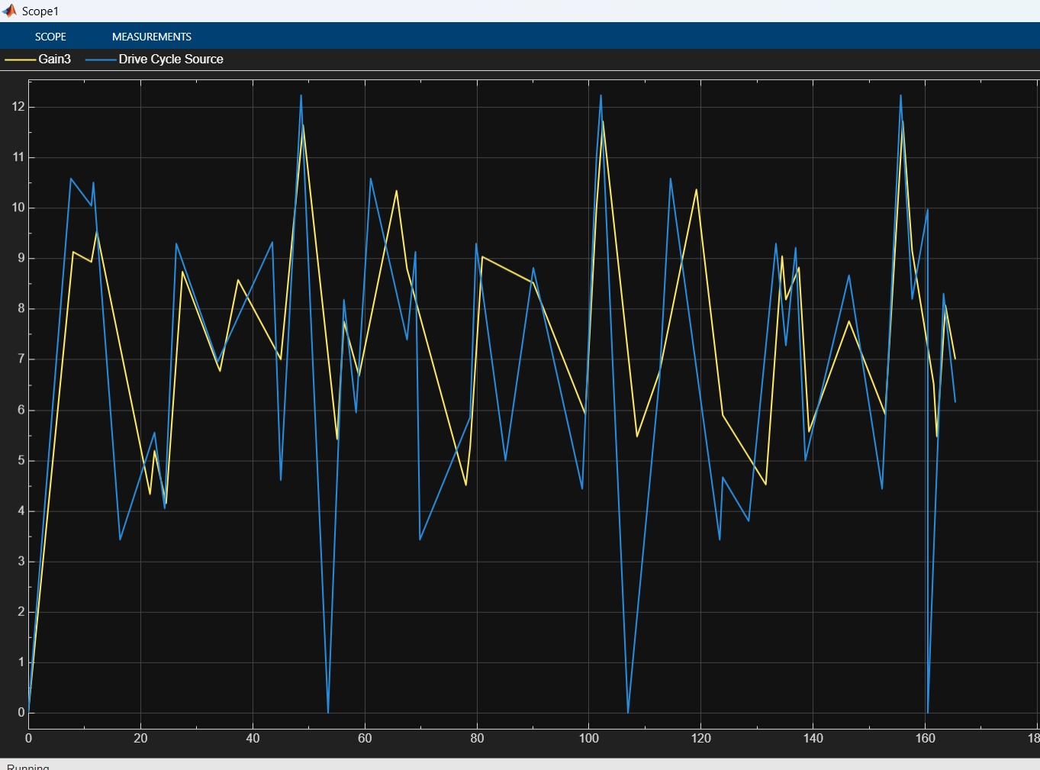
- The simulation achieved high fidelity, proving the digital twin’s capacity to emulate real driving behavior accurately.

5.2 Analysis of Results
The obtained results reveal that the Digital Twin Model effectively replicates the real vehicle’s dynamic response. The low deviation rates confirm precise parameter calibration and strong correlation between the virtual and physical systems.
Minor deviations (3–9%) were primarily caused by:
- Terrain irregularities not captured in the Simulink model.
- Heat losses and internal battery variations not fully modeled.
- Sensor noise and data latency during wireless transmission.
Overall, the energy consumption rate (Wh/km) deviated by less than 6%, indicating excellent energy efficiency modeling. The predictive capability of the model allows engineers to forecast future performance, maintenance needs, and optimal operating conditions for extended battery life and improved vehicle control.
CHAPTER 6
Discussion and Conclusion
6.1 Discussion
The project successfully demonstrated the implementation of a real-time Digital Twin for an Electric Vehicle that integrates both hardware and simulation environments. By coupling MATLAB–Simulink with microcontroller-based data acquisition, the system achieved continuous monitoring and predictive analysis capabilities.
Through this study, several significant insights were gained:
- A deep understanding of multi-domain modeling combining electrical, mechanical, and control subsystems.
- Development of real-time communication between the physical prototype and its digital replica using serial and UDP protocols.
- Practical experience in data calibration, noise filtering, and parameter tuning for system optimization.
- Exploration of IoT-based synchronization between embedded systems and simulation platforms.
The project also addressed key challenges such as timing mismatches in communication, model convergence stability, and noise management. Solutions like adaptive sampling, feedback tuning, and filtered data streaming were implemented to ensure accurate performance.

6.2 Conclusion
The Digital Twin Modeling and Simulation of an Electric Vehicle was successfully developed, implemented, and validated. The system accurately represented the electrical, mechanical, and dynamic behaviors of a real Electric ATV. Deviations between real and simulated data remained below 10%, demonstrating the model’s reliability.
The integration of MATLAB–Simulink with ESP32 microcontrollers enabled a real-time, data-driven feedback loop, creating a live digital replica of the vehicle. This approach reduces the need for repeated prototype testing, minimizes costs, and allows faster development cycles.
Hence, the project establishes a foundation for predictive maintenance, performance optimization, and smart electric vehicle design, emphasizing the future potential of digital twin technology in modern automotive engineering.

6.3 Future Scope
The current implementation can be extended in several promising directions:
- Regenerative Braking Integration:
Implementing regenerative energy recovery to enhance system efficiency and extend range.
- Thermal Management Modeling:
Including battery temperature regulation and heat dissipation mechanisms for better longevity.
- Machine Learning Integration:
Using AI models for predictive analytics, fault detection, and autonomous decision-making.
- Cloud-Based Dashboard:
Developing a remote web or mobile interface for continuous vehicle health monitoring and analytics visualization.
- Hardware-in-the-Loop (HIL) Testing:
Expanding the simulation into real-time embedded environments for control system validation.
These improvements can evolve the digital twin into a more intelligent, self-optimizing system for next-generation EV platforms.

  - Individual’s Contribution
This project, titled Digital Twin Modeling and Simulation of an Electric Vehicle Using MATLAB–Simulink, was successfully executed through the collaborative efforts of all team members, each contributing distinct skills and technical expertise across software, hardware, and analysis domains. The coordinated teamwork and division of responsibilities ensured the seamless integration of simulation and hardware components, resulting in an accurate and efficient digital twin model.

1. Nikita Gashiganti (1032231602)
Nikita Gandhi was responsible for the hardware interfacing and embedded system integration aspects of the project. Her primary focus was on configuring and deploying the STM32 microcontroller for real-time data acquisition and synchronization with MATLAB. She developed the interfacing logic required to gather data from multiple sensors, including current, voltage, and temperature modules, and implemented serial communication protocols for accurate data transfer.
Nikita also contributed to setting up sensor calibration and filtering mechanisms, ensuring that noisy or erroneous readings were corrected before being transmitted to the Simulink environment. She worked extensively with ESP32 and STM32 communication layers, achieving a bidirectional data link between the virtual simulation and the physical prototype. Her technical insight into embedded systems and attention to hardware-software interfacing significantly contributed to the project’s success.
Additionally, she was instrumental in troubleshooting power and connectivity issues during testing phases, ensuring smooth integration between hardware components and MATLAB. Her understanding of microcontroller programming and real-time communication protocols helped stabilize the hardware platform for continuous operation during performance testing.

2. Yuvraj Karpe (1032232693)
Yuvraj Karpe focused on the battery modeling and energy management subsystem of the digital twin. His main contribution was the development and tuning of the NMC (Nickel Manganese Cobalt) battery model, which forms the backbone of the EV’s powertrain simulation. He implemented the Coulomb Counting method for SOC (State of Charge) estimation and validated it against experimental readings from the hardware setup.
Yuvraj also formulated energy efficiency and consumption algorithms to analyze discharge rates under different drive cycles. He worked on calibrating internal resistance and efficiency parameters within the battery subsystem, ensuring realistic representation of charge-depletion characteristics. His detailed analysis of the battery’s dynamic performance improved the correlation between the simulated and actual test data.
In addition to the battery modeling, Yuvraj managed the data logging and result validation phase, where he performed multiple test runs to compare simulated SOC and energy consumption with real-time readings. His work ensured that the deviation remained under 10%, confirming the fidelity of the digital twin. His contribution was vital in validating the overall accuracy and functionality of the EV powertrain model.

3. Divyansh Vij (1032231201)
Divyansh Vij contributed primarily to data analysis, visualization, and documentation. He was responsible for structuring the project documentation, preparing graphical results, and developing meaningful interpretations of the system’s performance metrics. His focus was on ensuring that all test results were accurately represented through graphs such as Voltage vs SOC, Velocity vs Time, and Real vs Simulated Speed.
Divyansh played a key role in generating comprehensive visual reports that correlated the simulated and real-world data. Using MATLAB’s plotting and statistical analysis tools, he developed customized data visualization dashboards that facilitated performance assessment and model validation.
Moreover, he managed the final project report, ensuring clarity, organization, and technical precision across all sections. His attention to academic structure and presentation helped in transforming complex experimental results into an accessible and well-documented technical paper. His consistent coordination with team members ensured that both software and hardware findings were effectively integrated within the report.

4. Harshit Agarwal (1032231605)
Harshit Agarwal was the lead designer and developer of the MATLAB–Simulink model. He conceptualized, designed, and implemented the digital twin simulation environment, incorporating electrical, mechanical, and control systems within a unified platform. His major contribution involved the development of the PMSM (Permanent Magnet Synchronous Motor) control logic, torque equations, and the inverter PWM subsystem.
He worked on defining the mathematical models that governed powertrain dynamics, including battery SOC estimation, torque control, and vehicle motion equations. Harshit also ensured that the virtual model responded accurately to varying drive cycles and sensor feedback from the hardware system. Through iterative calibration, he fine-tuned model parameters such as motor efficiency, gear ratios, and aerodynamic coefficients to minimize deviations from real-world data.
Additionally, Harshit played a central role in integrating the hardware feedback loop into the Simulink environment, enabling real-time interaction between physical sensors and the virtual model. He supervised the system’s testing and calibration phases, ensuring synchronization stability and data accuracy.
Harshit also provided technical leadership in coordinating simulation and hardware teams, guiding system-level debugging, and validating the final results. His deep understanding of control systems, MATLAB, and embedded modeling was pivotal in achieving a successful and accurate digital twin implementation.

INSTRUCTIONS FOR THE STUDENTS:
- Edit only the red colored part in the first page called the Title page. The first page should not have the page number
- Modify table of content as per your project report (Page number and subtopic headings etc.)
- Once the table of content is complete, hide the table border, delete the red text from 6.2 (added for your reference)
- Similarly hide the table border for list of Figures and Tables
- The Chapters flow should be as per the table of contents given
- Every chapter should have Chapter Number and Chapter Name as shown on page number 8 and 9
- For all chapters use the Font as “Times New Roman” and 1.5 line spacing, all paragraphs text should be aligned to justify
- Use Font Size-14pts, BOLD, ALL Capital letters for Chapter Number and Chapter Name
- Refer the below styles for heading in a chapter
  - Heading1 - 12pts Times New Roman, Bold, Flush Left
  - Heading2 - 12pts Times New Roman, Bold, Flush Left
  - Heading3 - 12pts Times New Roman, Bold and Italic, Flush Left
  - Heading4 - 12pts Times New Roman, Bold, Flush Left
  - Equations- (Use Equation Editor)
  - Figures- Figures should be aligned to center, Figure name should be below the figure (centrally aligned) named as “Figure 1: Figure_Title”
  - Tables- tables should also be centrally aligned, In case of large tables select the fit to page option. Table title should be above the table named as “Table 1: Table title”
- The header footer should be only for the chapters and not for the initial pages. Every chapter should have the header and footer as shown in the FORMAT

